**THE ALEXAMARA MARINA GROUP DATABASE**

Alexamara Marina Group offers in-water boat storage to owners by providing boat slips that boat owners can rent on an annual basis. Alexamara owns two marinas: (1) Alexamara East and (2) Alexamara Central. In addition to boat slips, Alexamara also provides a variety of boat repair and maintenance services to the boat owners who rent the slips. Alexamara stores in a database the data it needs to manage its operations.

In the **Marina** table Alexamara stores information about its two marinas. A marina number uniquely identifies each marina. The table also includes the marina name, address, city, state, and zip code.

Alexamara stores information about the boat owners to whom it rents slips in the **Owner** table. An owner number that consists of two uppercase letters followed by a two-digit number uniquely identifies each owner. For each owner, the table also includes the last name, first name, address, city, state, and zip code.

Information about the slips in the marinas is contained in the **MarinaSlip** table. The table contains the slip ID, marina number, slip number, length of the slip (in feet), annual rental fee, name of the boat currently occupying the slip, type of boat, and boat owner’s number.

Alexamara provides boat maintenance service at its two marinas. The types of service provided are stored in the **ServiceCategory** table. A category number uniquely identifies each service that can be performed, along with a description of the category.

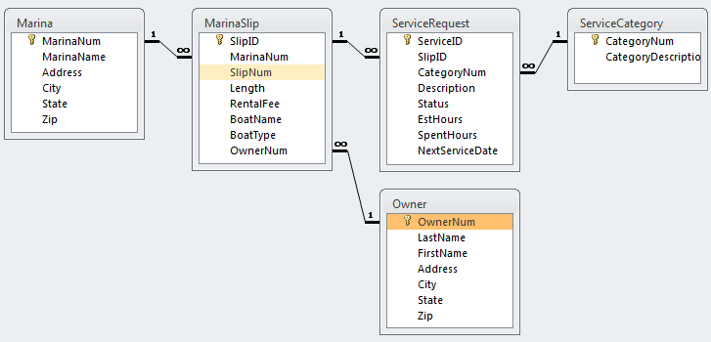Information about the services requested by owners is stored in the **ServiceRequest** table. Each row in the table contains a service ID that identifies each service request. The slip ID identifies the location of the boat to be serviced. The ServiceRequest table also contains the category number of the service to be performed, a description of the specific service to be performed, and the current status of the service. The table also contains the estimated number of hours required to complete the service. For completed jobs, the table contains the actual number of hours it took to complete the service. If another appointment is required to complete additional service, the appointment date appears in the NextServiceDate column.